**Delete function:**

Delete room in the data.service.ts

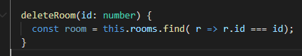

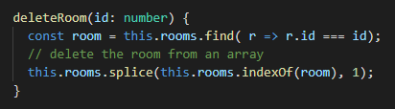

The method will return an any or return a null

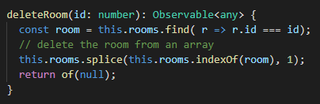

Now, create the deleteUser()

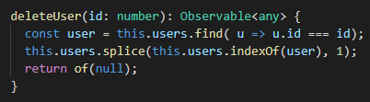

Last, resetUserPwd()

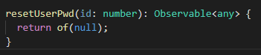

Implement the methods in the users-detail.component.ts

deleteUser()

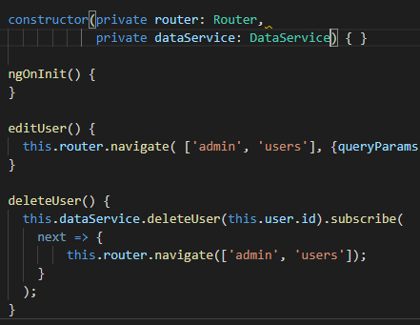

Hook up the delete button

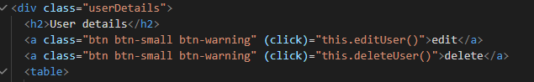

Test it

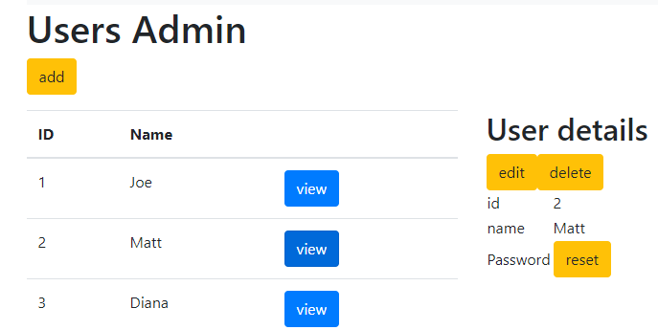

Click delete to remove user Matt

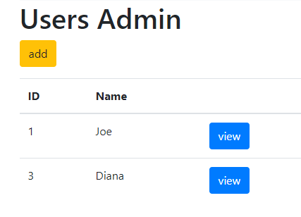

Code the resetPwd()

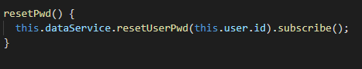

Hook up the reset password



Now, in the room-details.component.ts implement the delete method

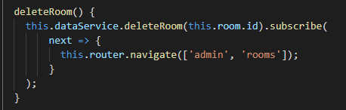

Hook up the button

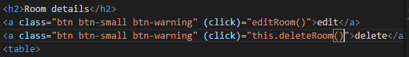

Test it!

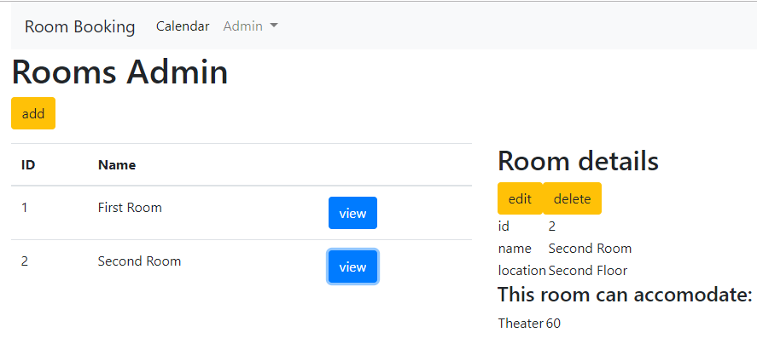

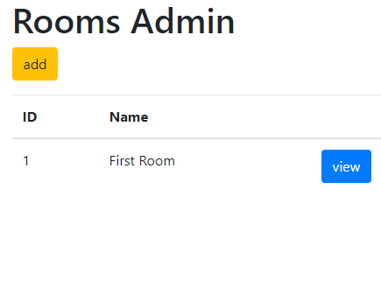

We need to clear the rooms edit view.

Add this.action = null; to the top of the this.route.queryParams.subscribe()

In rooms.component.ts file

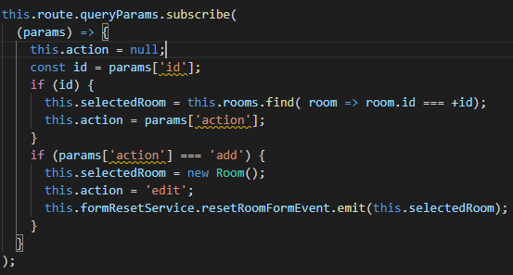

Try again

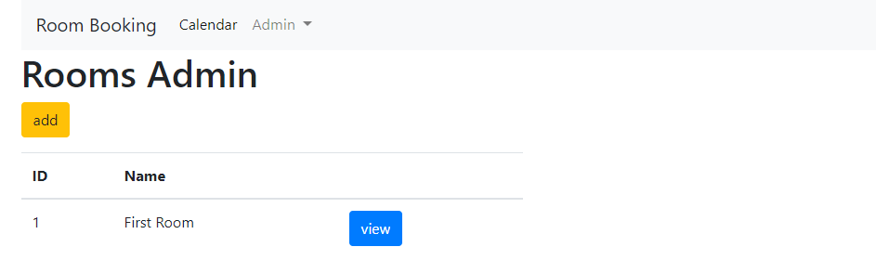

It works!